Assignment – 06:
Upload a static website on S3.

Steps:
- Create a public bucket like usual where we will be uploading our static website.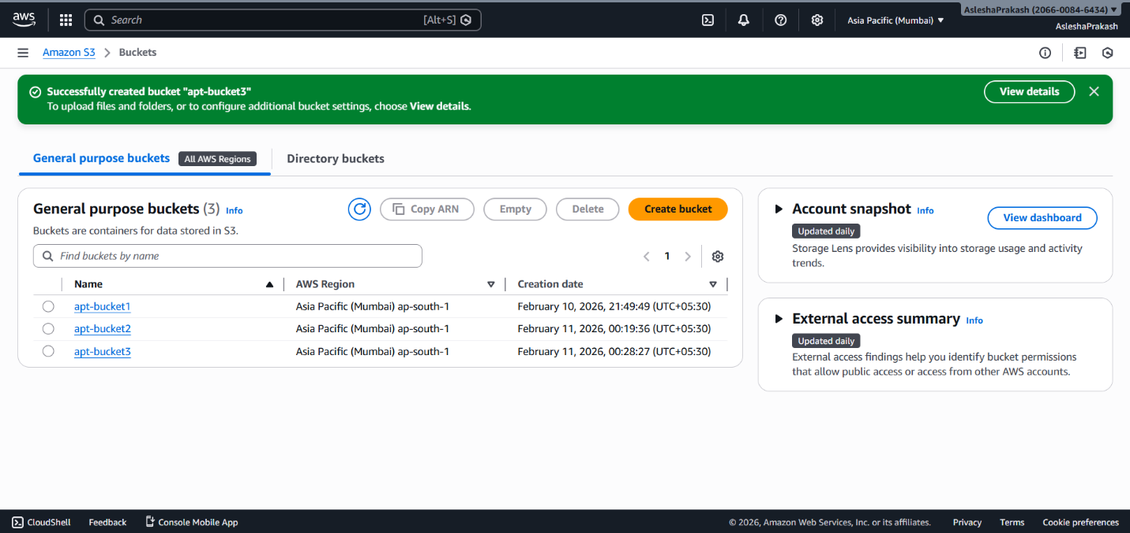

- Select the public bucket and scroll to the bottom of its Properties to find the Static website hosting section and click Edit.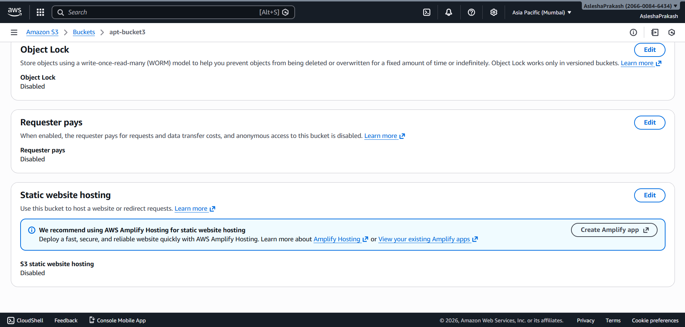

- Enable Static website hosting and host a static website option under Hosting type. Then specify the Index document file name. Here we have index.html as it.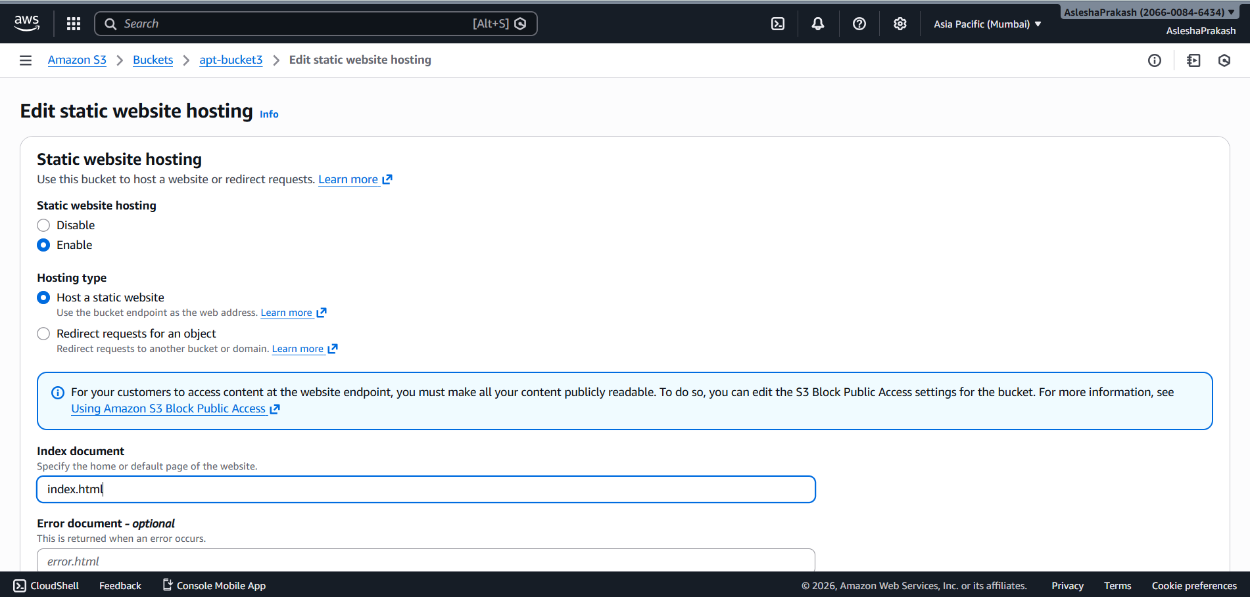

- Let the rest of the things be default and click on Save Changes.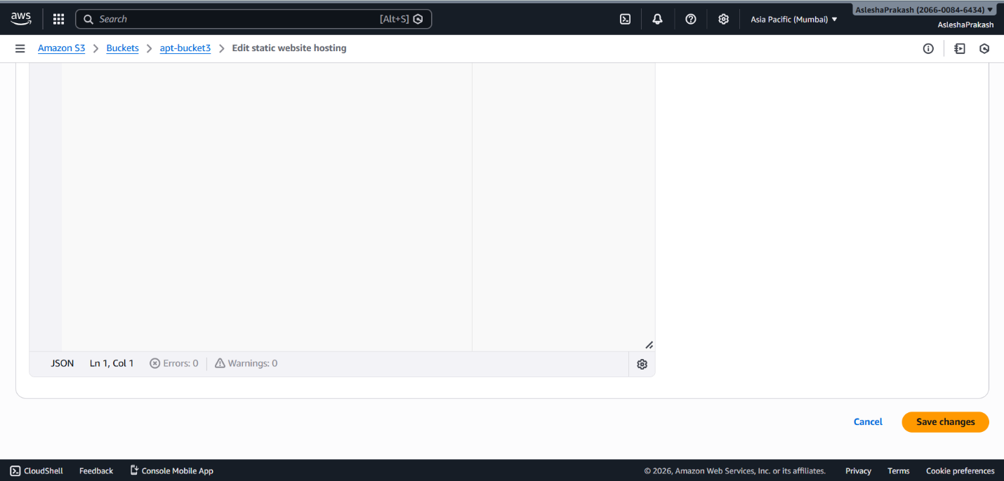

- The green confirmation banner marks successful static website hosting.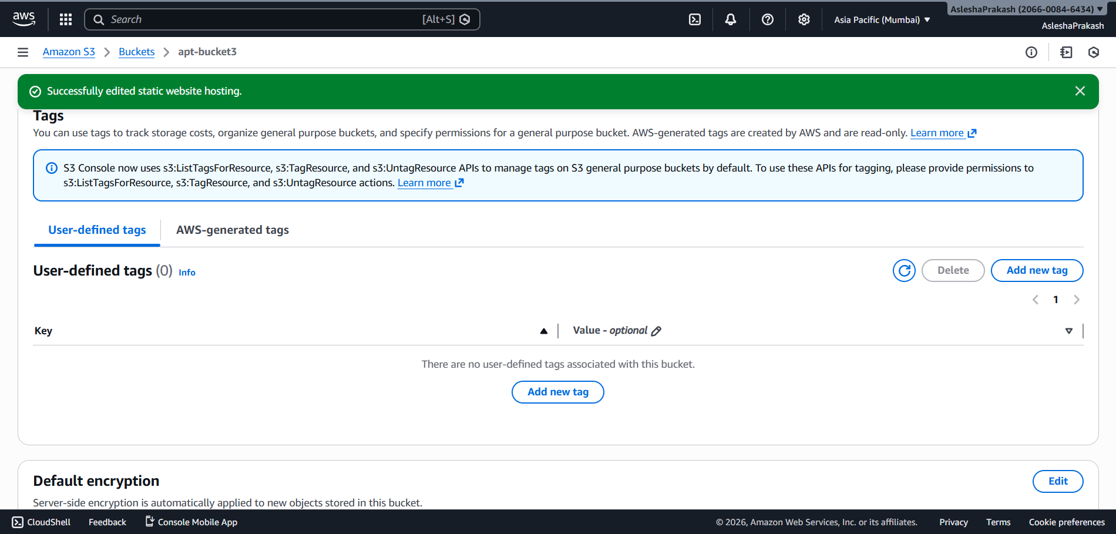

- Go to Upload section and upload the html files created for the static website. Click on Upload button next. 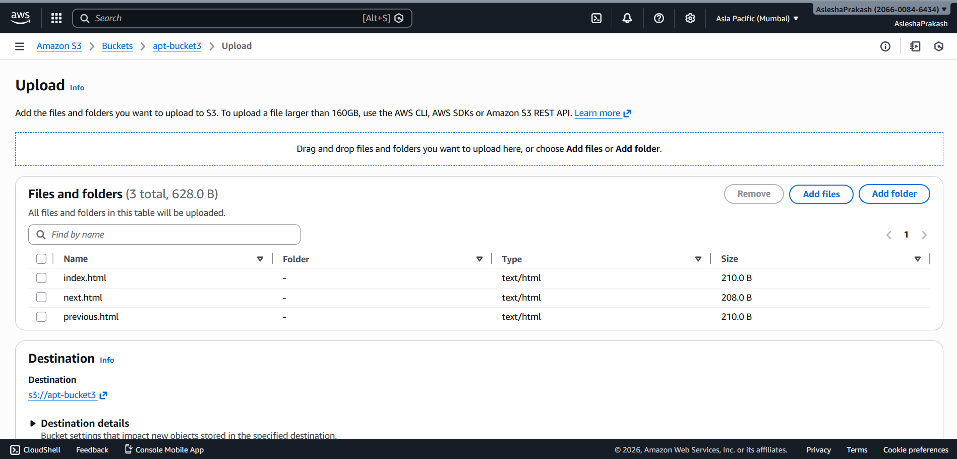

- Confirmation message will appear on successful upload. Click on Close button.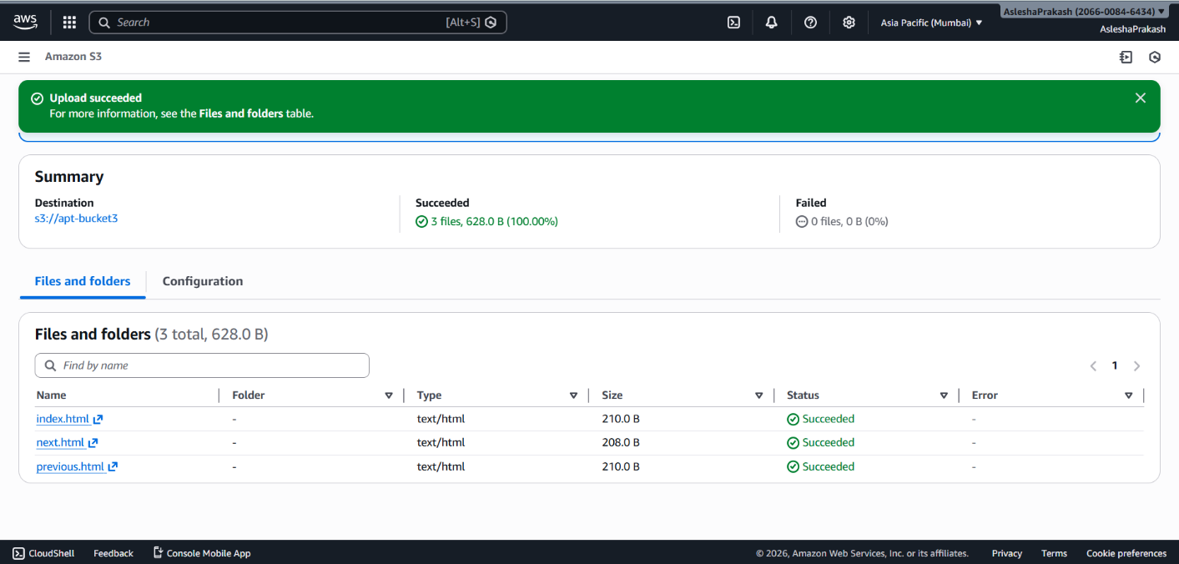

- Select all the files and click on the Actions dropdown button and click on the Make public using ACL option.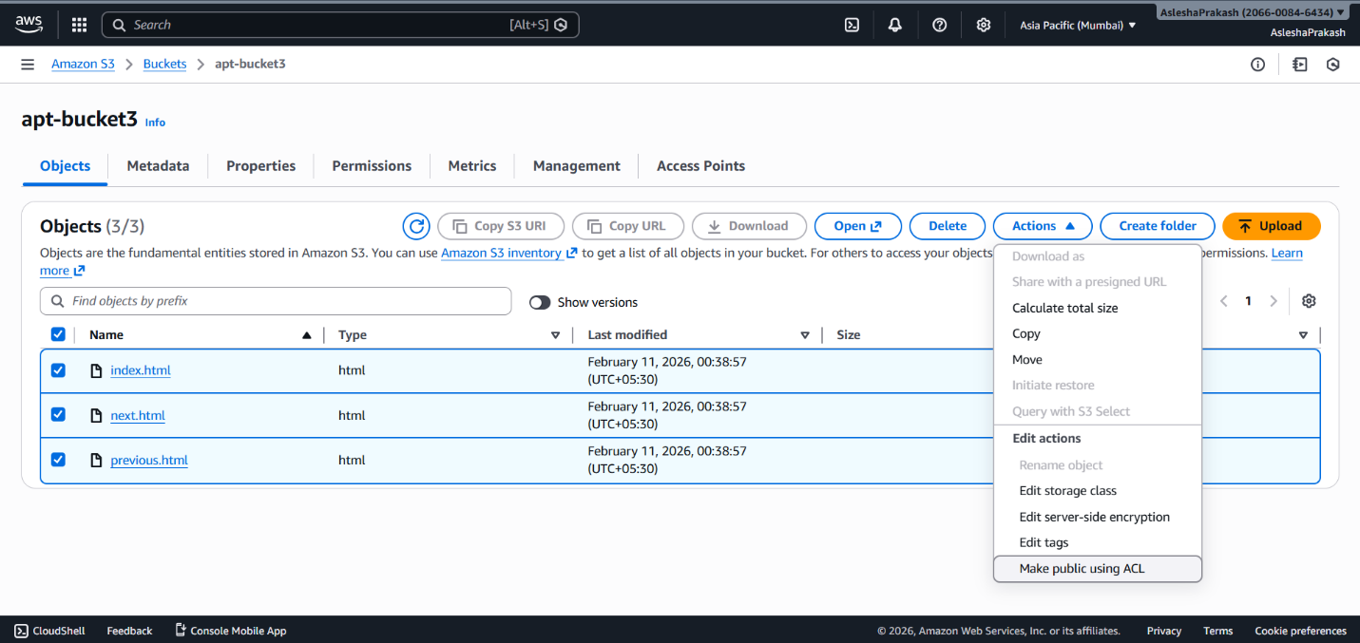

- A page like the following will appear. Click on Make public button.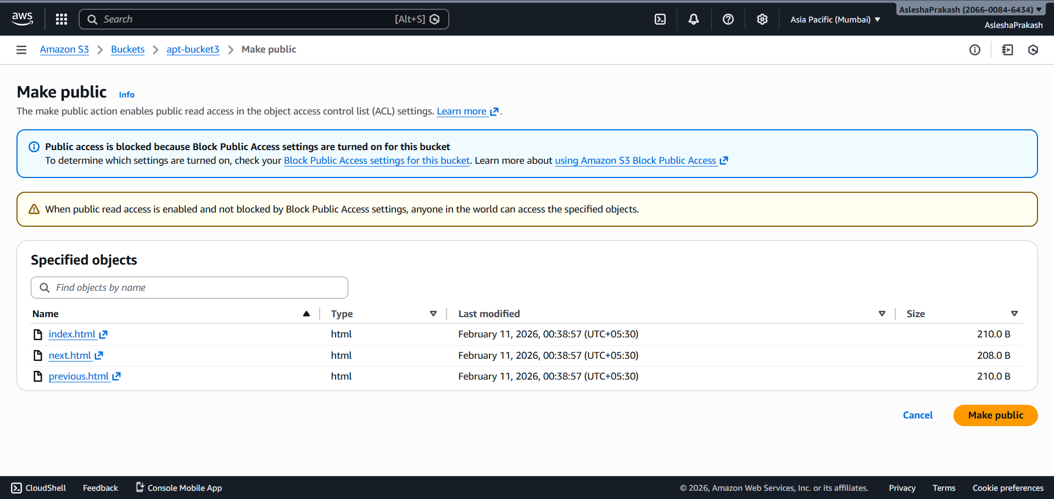

- Confirmation banner indicates succesful public access. Click Close.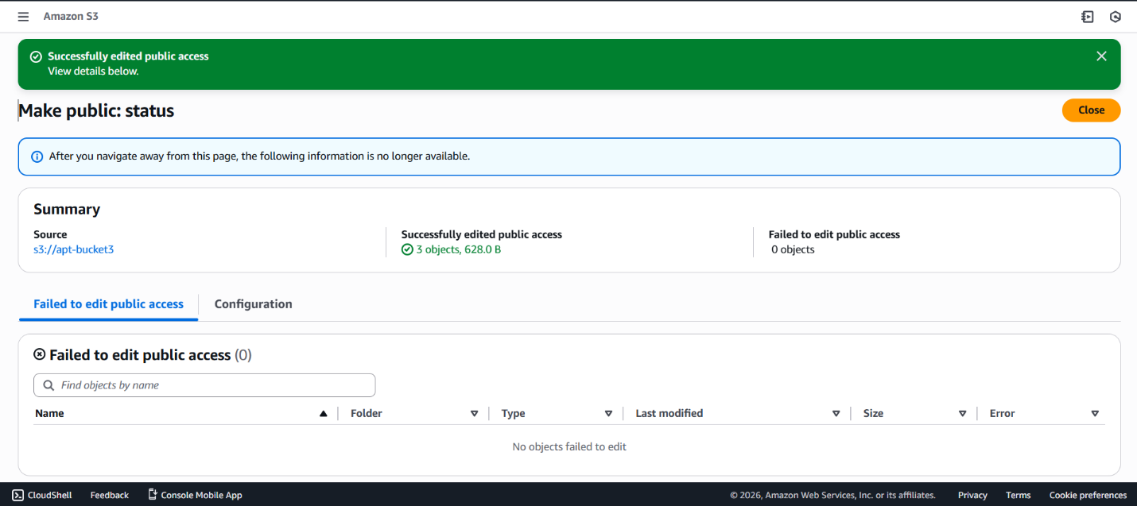

- Open index.html file.

- Copy Object URL and paste it in new tab to see the website running.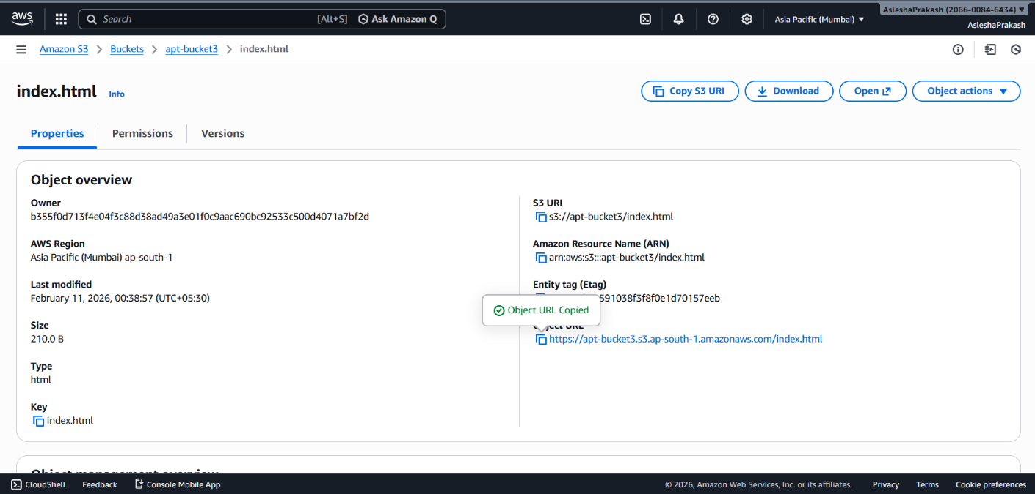

- The website running: